Steps: Master Page/Images/CSS

Steps:

Step1:

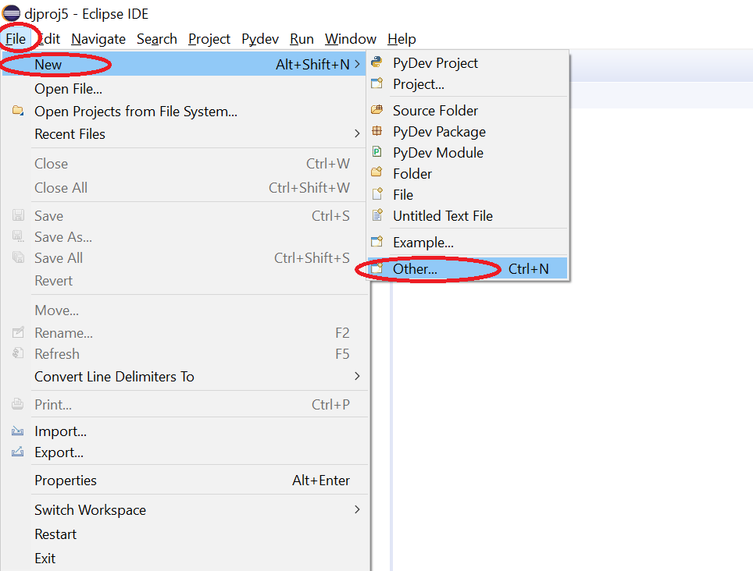

Step 2:

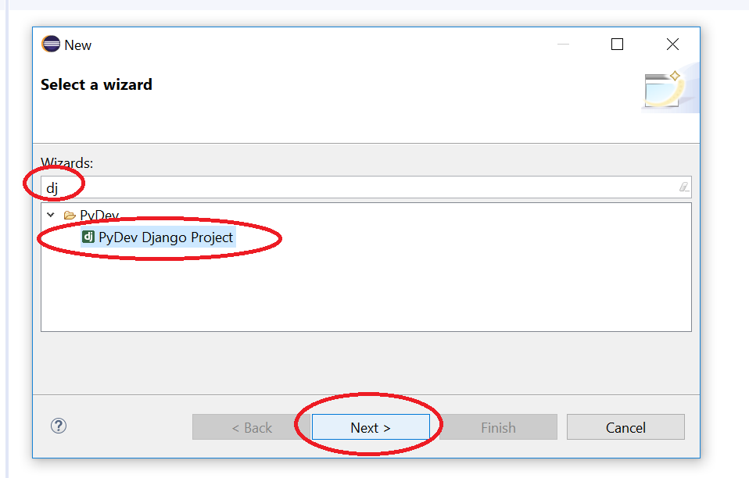

Step 3:

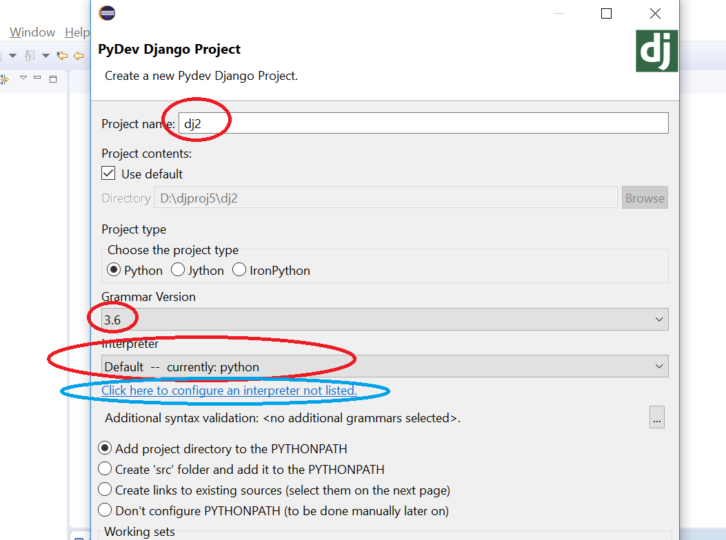

Step 4:

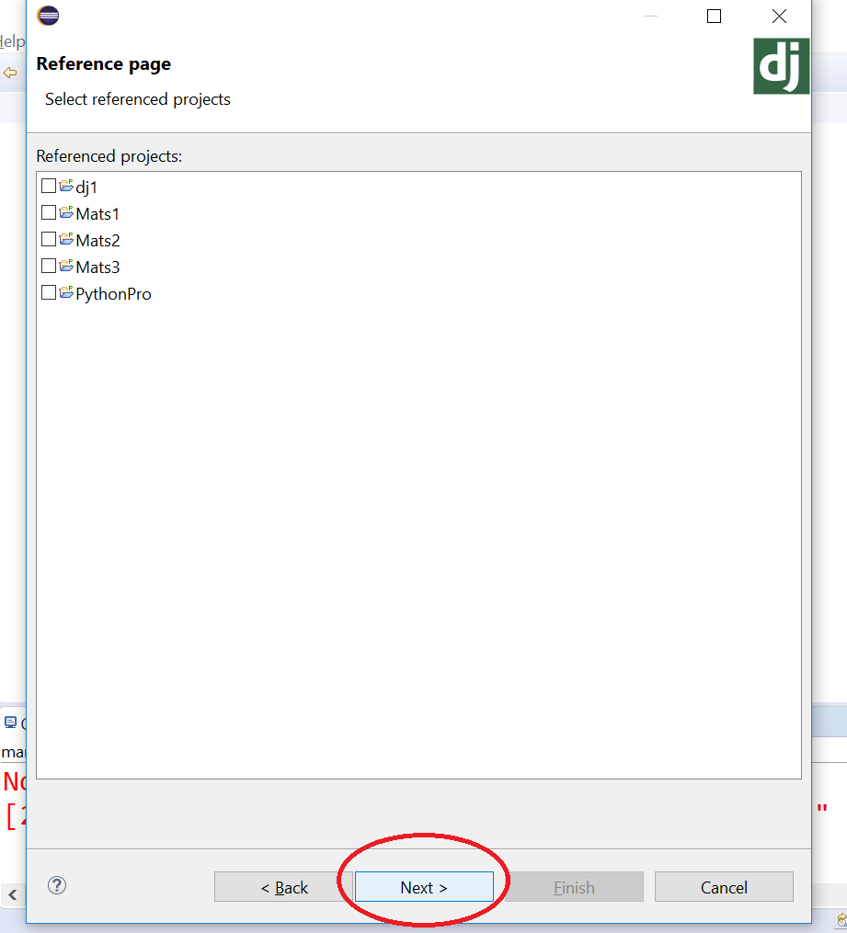

Step 5:

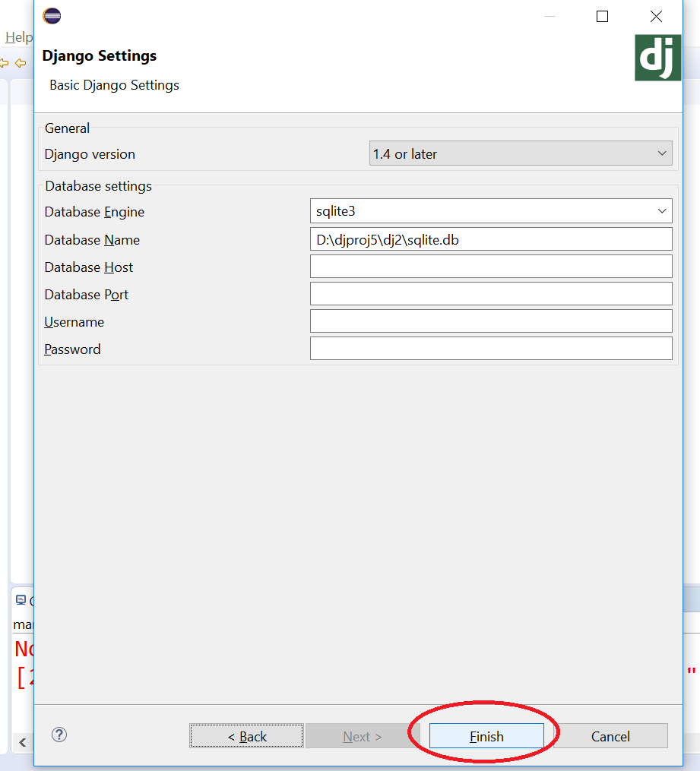

Step 6: Create Application say college

Right click on Django project

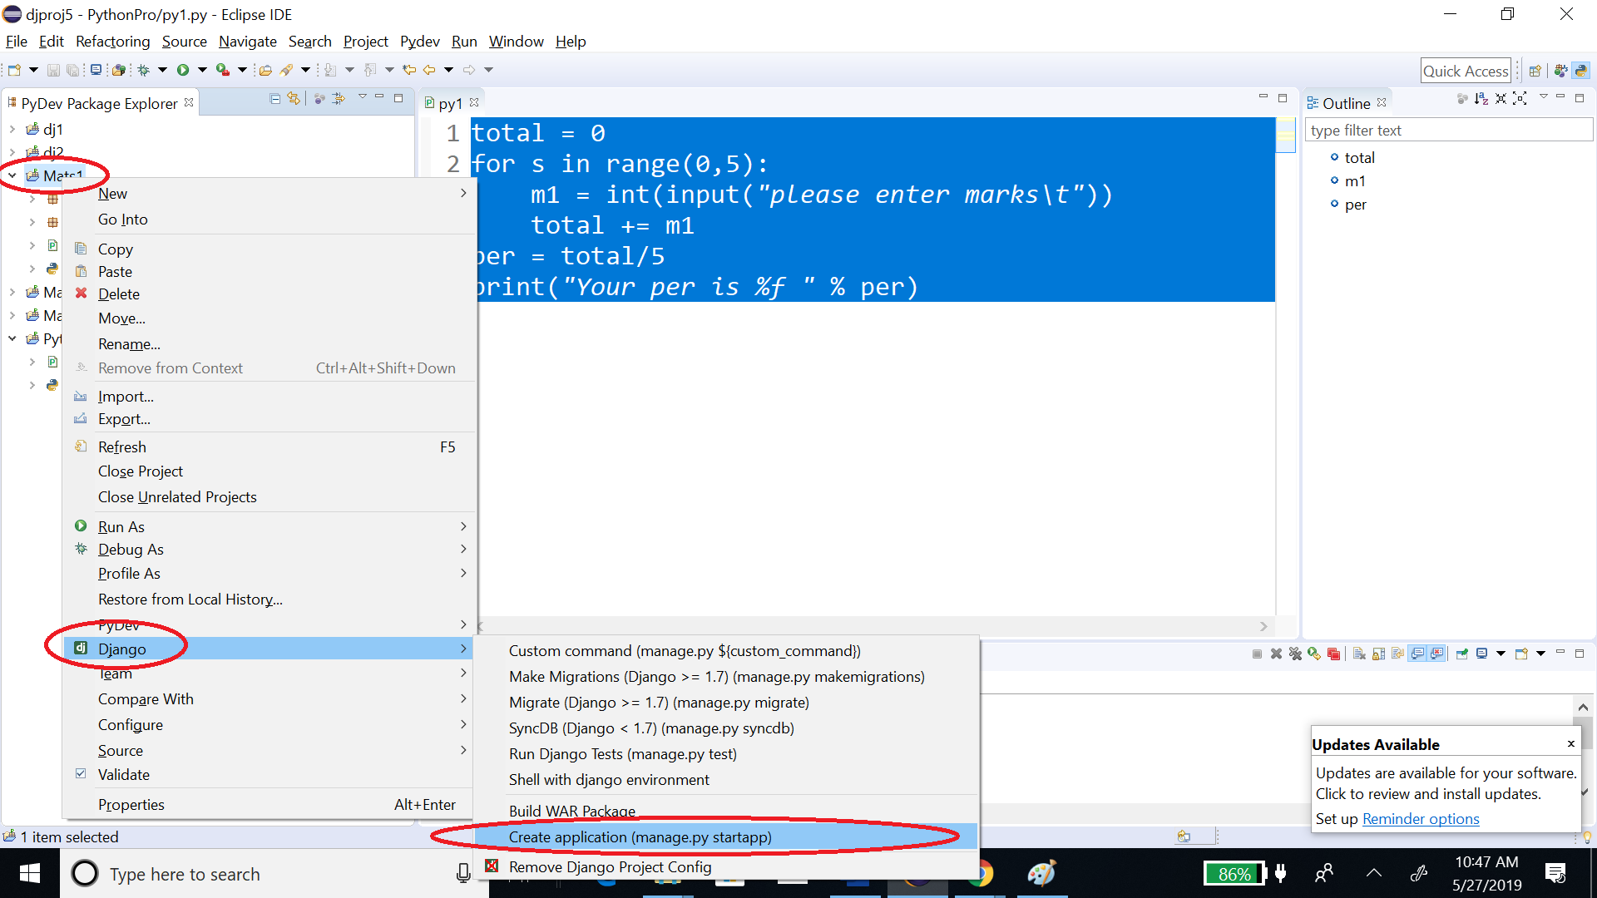

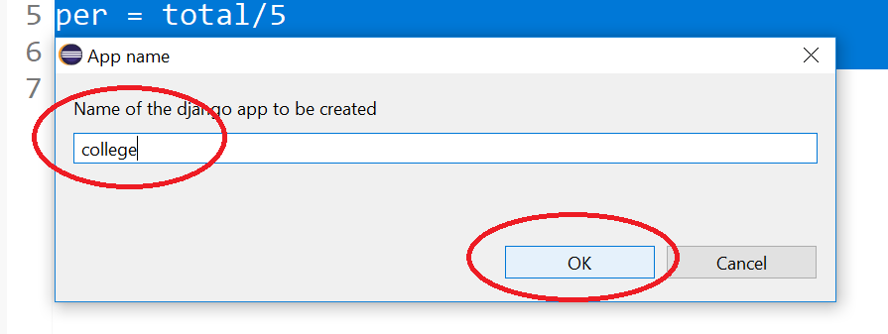

Go to project settings.py add your new module say ‘college’:

INSTALLED_APPS = [

'django.contrib.admin',

'django.contrib.auth',

'django.contrib.contenttypes',

'django.contrib.sessions',

'django.contrib.messages',

'django.contrib.staticfiles',

'college',

]

Go to urls.py in the main folder and write following:

from django.contrib import admin

from django.urls import path

from django.urls.conf import include

urlpatterns = [

path('college/', include('college.urls')),

path('admin/', admin.site.urls),

]

Create a urls.py inside college app (college is your app/module name) and write following:

from django.contrib import admin

from django.urls import path

from college import views

urlpatterns = [

path('home/', views.home),

path('about/', views.about),

path('contact/', views.contact),

]

Go to module views.py and add following:

from django.shortcuts import render

# Create your views here.

def home(req):

return render(req, "index.html", {"name": "EFFCON"})

def about(req):

return render(req, "about.html")

def contact(req):

return render(req, "contact.html")

Create base.html, index.html, about.html, contact.html:

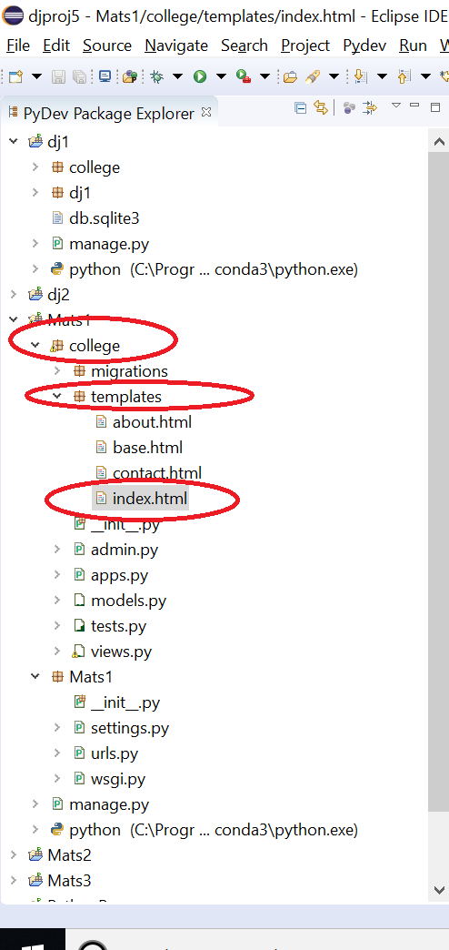

Inside base.html:

<link href="/static/style.css" rel="stylesheet" />

<h1>Logo</h1>

<p>

<a href="../home">Home</a>

<a href="../about">About</a>

<a href="../contact">Contact</a>

</p>

{% block content %}

{% endblock %}

<p>Copyright @ bla bla</p>

Inside index.html:

{% extends 'base.html' %}

{% block content %}

<h1>Welcome {{name}}</h1>

<h1>I am Index</h1>

<img src="/static/images/a4.jpg" />

{% endblock %}

Inside about.html:

{% extends 'base.html' %}

{% block content %}

<h1>I am index</h1>

{% endblock %}

Inside contact.html:

{% extends 'base.html' %}

{% block content %}

<h1>Contact Us...</h1>

{% endblock %}

Create static folder inside college app, inside static folder create images folder, put your images in images folder, create a css file named style.css inside static folder:

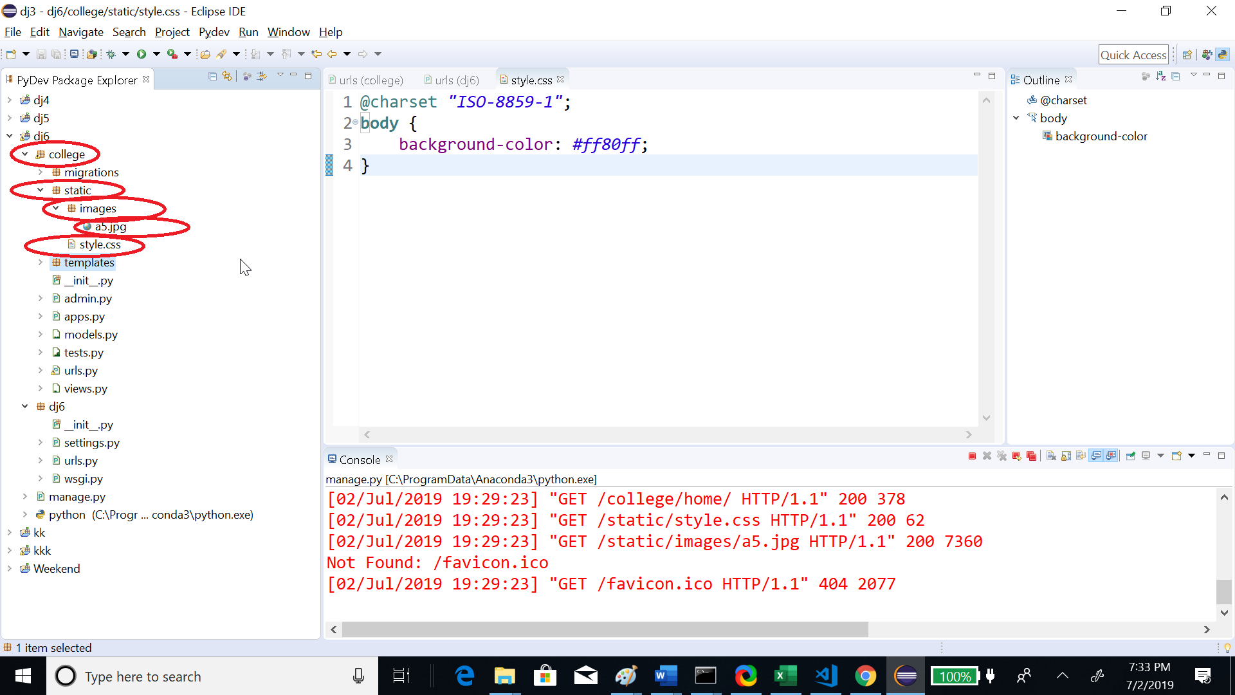

Inside style.css write following code:

body {

background-color: #ff80ff;

}

Then Run the Project:

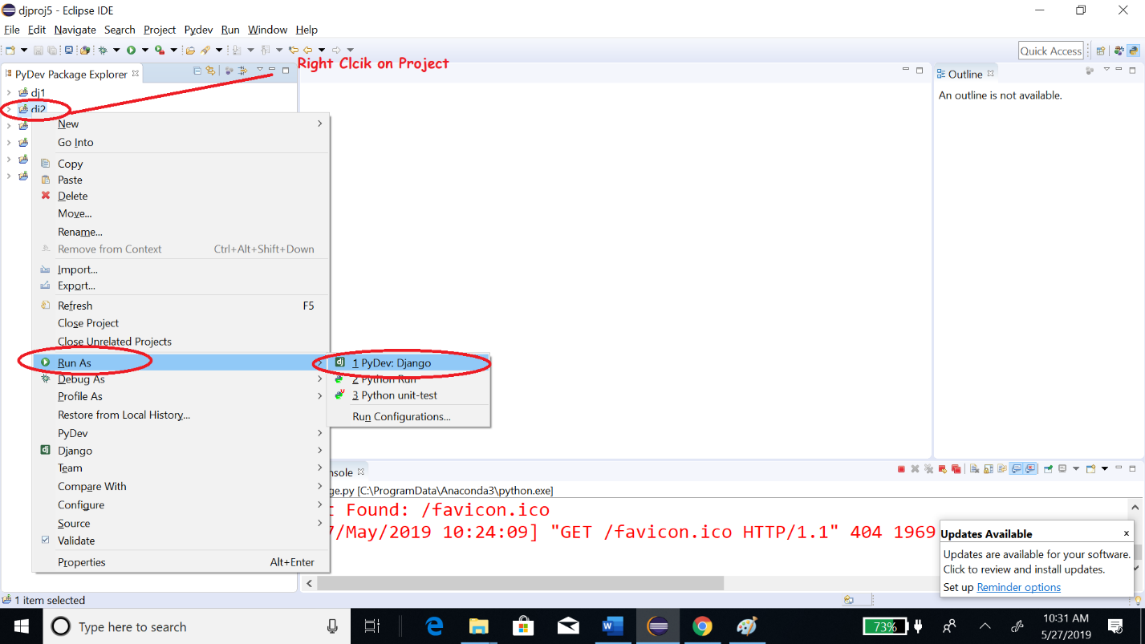

Go to url:

<http://127.0.0.1:8000/college/home/>